The report of Rest assured Api:

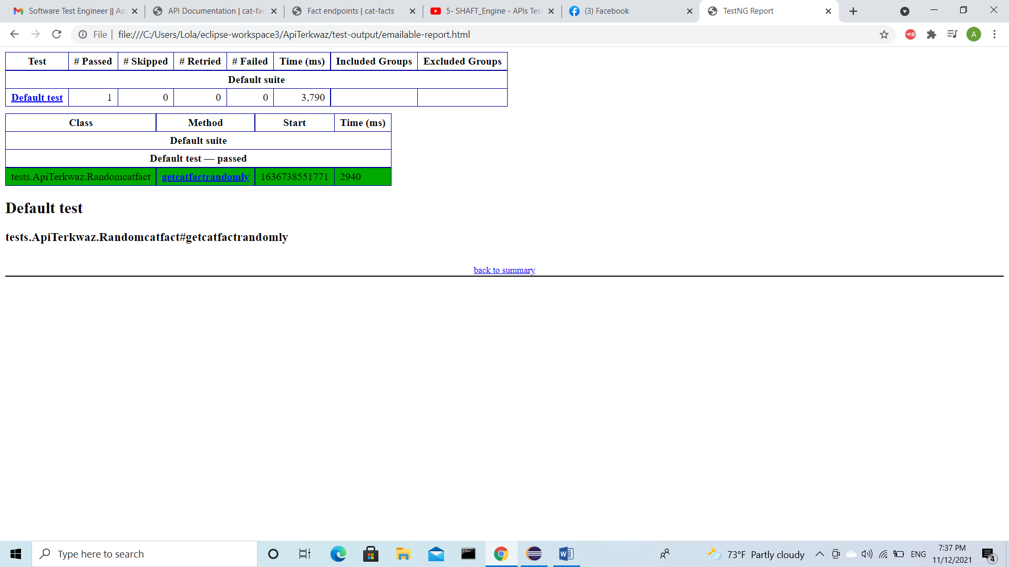

**The response body of random catfact:**

{

"status": {

"verified": true,

"sentCount": 1

},

"_id": "5a4d76736ef087002174c289",

"updatedAt": "2020-08-23T20:20:01.611Z",

"createdAt": "2018-06-18T20:20:02.372Z",

"user": "5a9ac18c7478810ea6c06381",

"text": "The lightest cat on record is a blue point Himalayan called Tinker Toy, who weighed 1 pound, 6 ounces (616 g). Tinker Toy was 2.75 inches (7 cm) tall and 7.5 inches (19 cm) long.",

"deleted": false,

"source": "user",

"__v": 0,

"type": "cat",

"used": false

}